**SCHOOL OF COMPUTER SCIENCE**

**UNIVERSITY OF PETROLEUM AND ENERGY STUDIES**

**DEHRADUN, UTTARAKHAND**



**DATA COMMUNICATION AND NETWORKS LAB**

**LABORATORY FILE**

**(2024-2025)**

**For**

**Vth Semester**

**Submitted To: Submitted By:**

Prof. Abhishek Yadav Mr. Akshat Negi

Assistant Professor S.S. 500106533(SAP ID)

[Vth Semester] R2142220414(Roll No.)

School of Computer Sciences B.Tech. CSF (Batch-1)

**LAB EXPERIMENT – 9  
Distance Vector Routing Simulation Using Cisco Packet Tracer – RIP Table**

**Set Up the Devices**

1. **Open Cisco Packet Tracer.**
2. Drag and drop the following devices:
   * **1 Router**
   * **2 Switches**
   * **4 PCs**
3. Connect the devices using the appropriate cables:
   * **Router to Switches**: Use a **crossover cable** or an **automatic cable** to connect the router's GigabitEthernet port to each switch.
   * **Switch to PCs**: Use a **straight-through cable** or an **automatic cable** to connect each PC to a switch.

**Assign IP Addresses**

Assign IP addresses to the PCs in two subnets. Assume:

* **Subnet 1**: 192.66.1.0/24
* **Subnet 2**: 10.0.0/24

|  |  |  |
| --- | --- | --- |
| **Device** | **IP Address** | **Default Gateway** |
| PC0 (Switch 1) | 192.66.1.1 | 192.66.1.6 |
| PC1 (Switch 1) | 192.66.1.2 | 192.66.1.6 |
| PC2 (Switch 2) | 10.0.0.3 | 10.0.0.4 |
| PC3 (Switch 2) | 10.0.0.2 | 10.0.0.4 |

Configure PC1 with giving IP Address as **192.66.1.2**

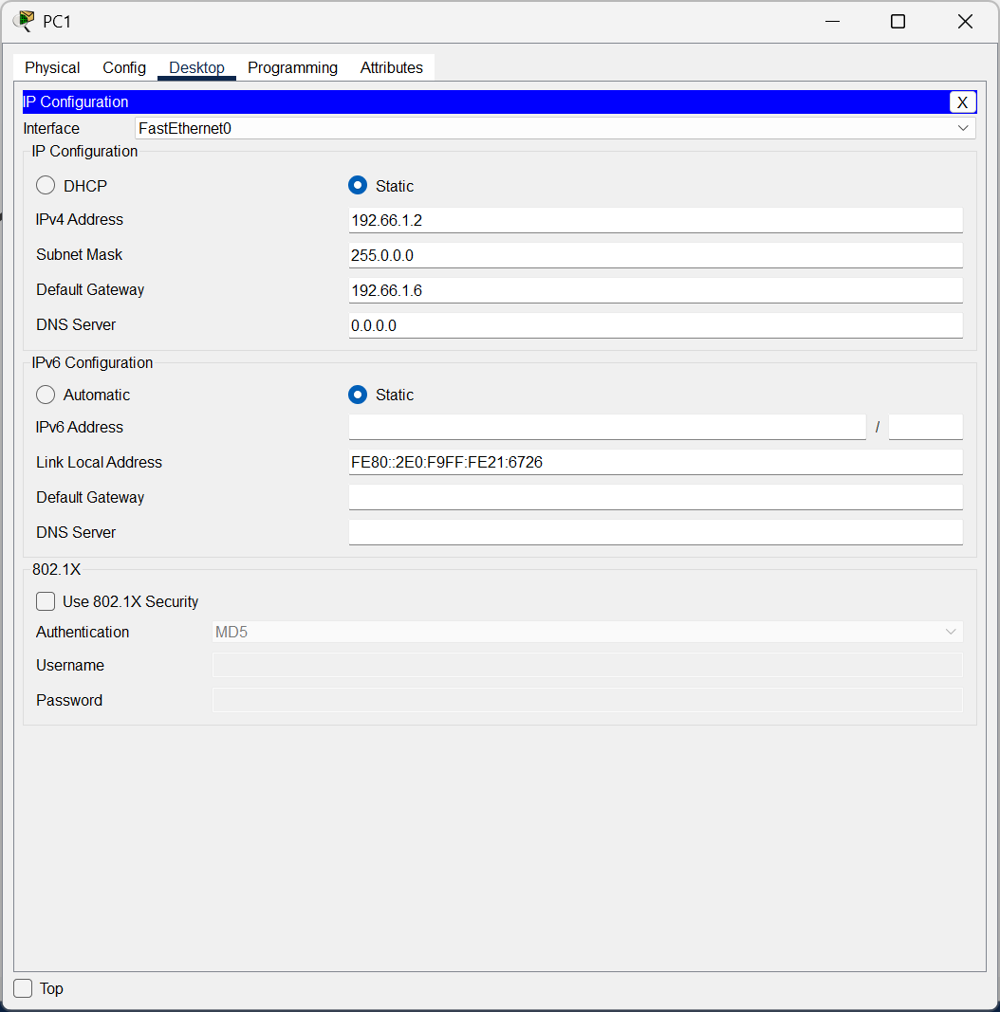

Configure PC0 with giving IP Address as **192.66.1.1**

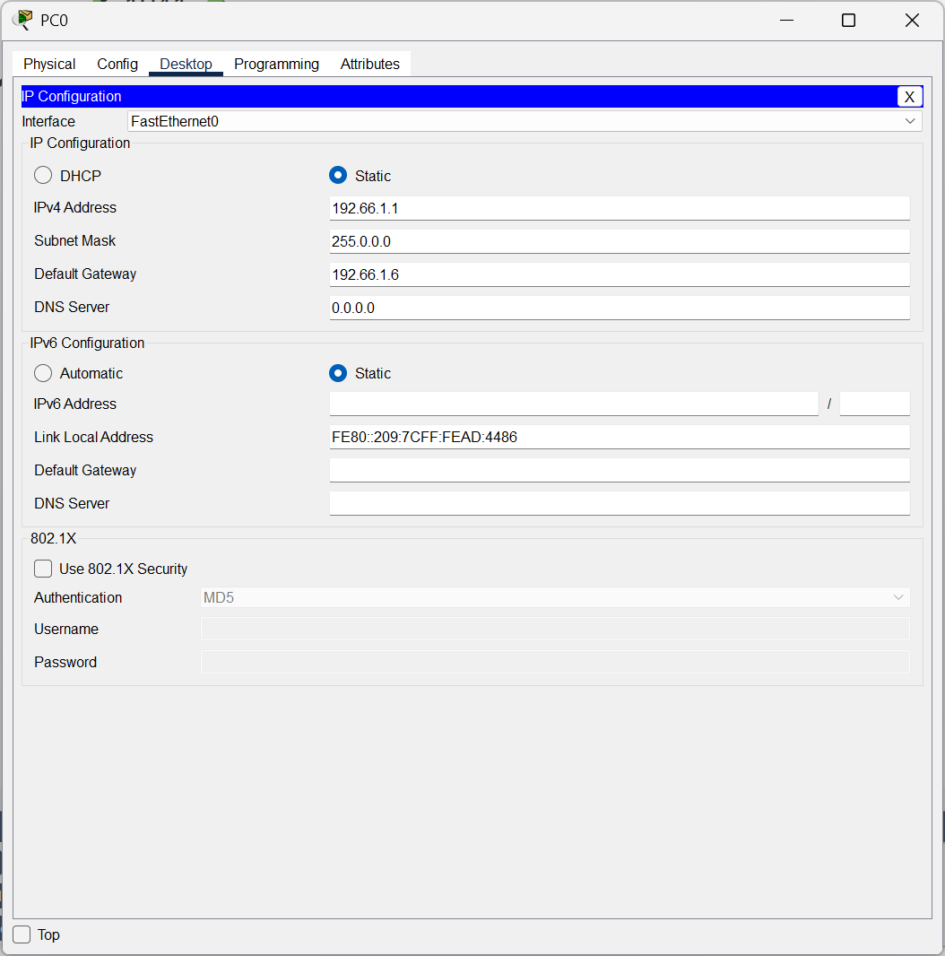

Configure Router0 with giving IPv4 Address as **192.66.1.6 for the network 1.**

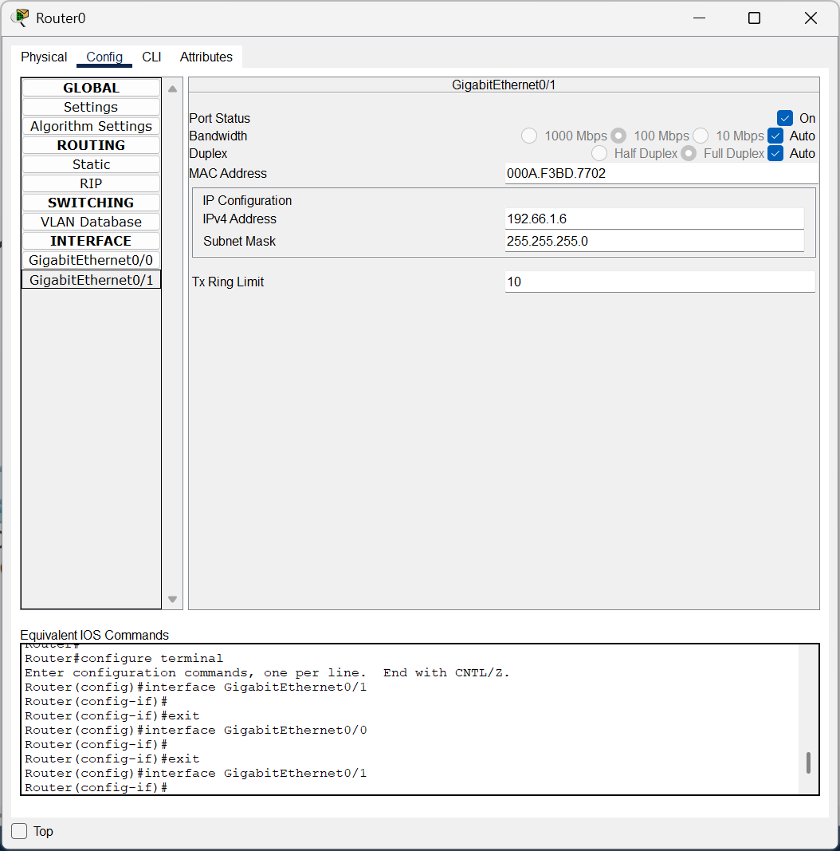

Configure PC2 with giving IP Address as **10.0.0.3**

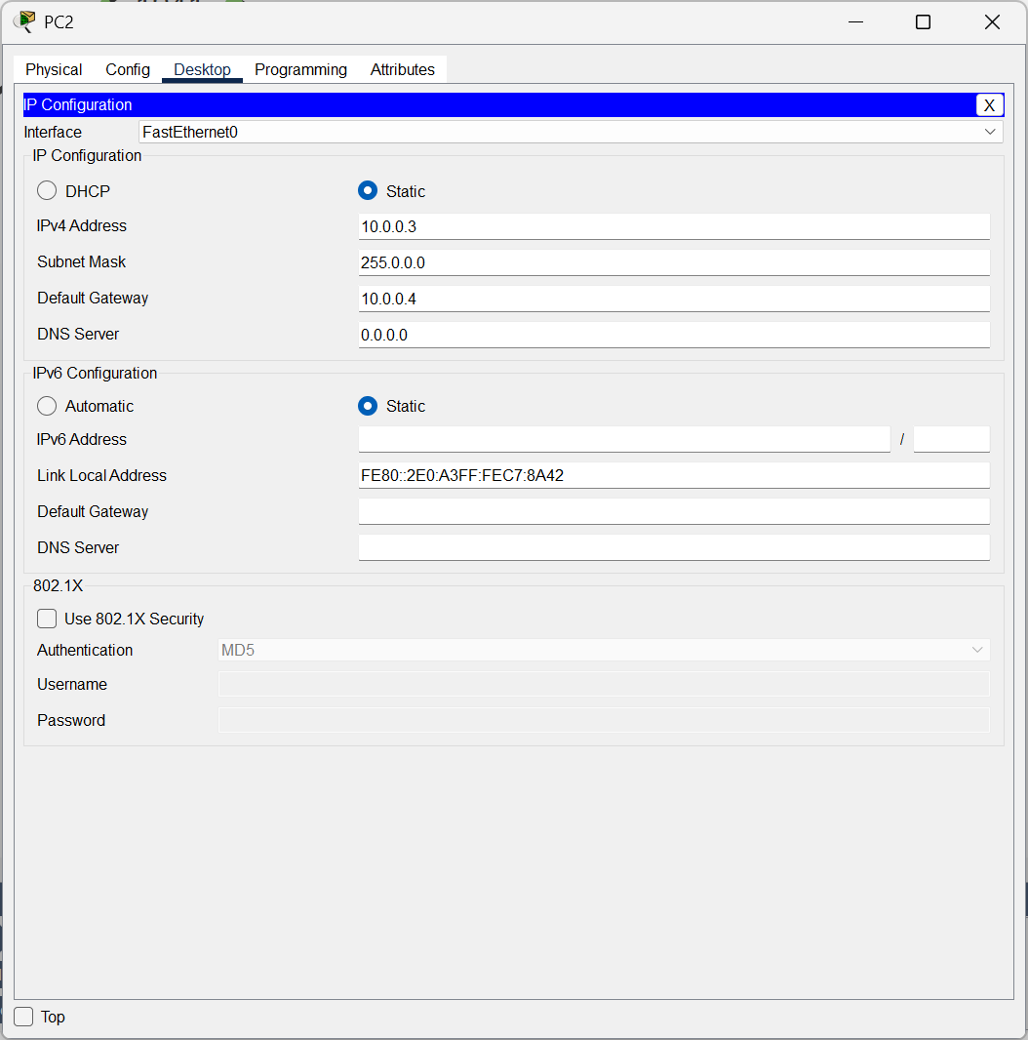

Configure PC3 with giving IP Address as **10.0.0.2**

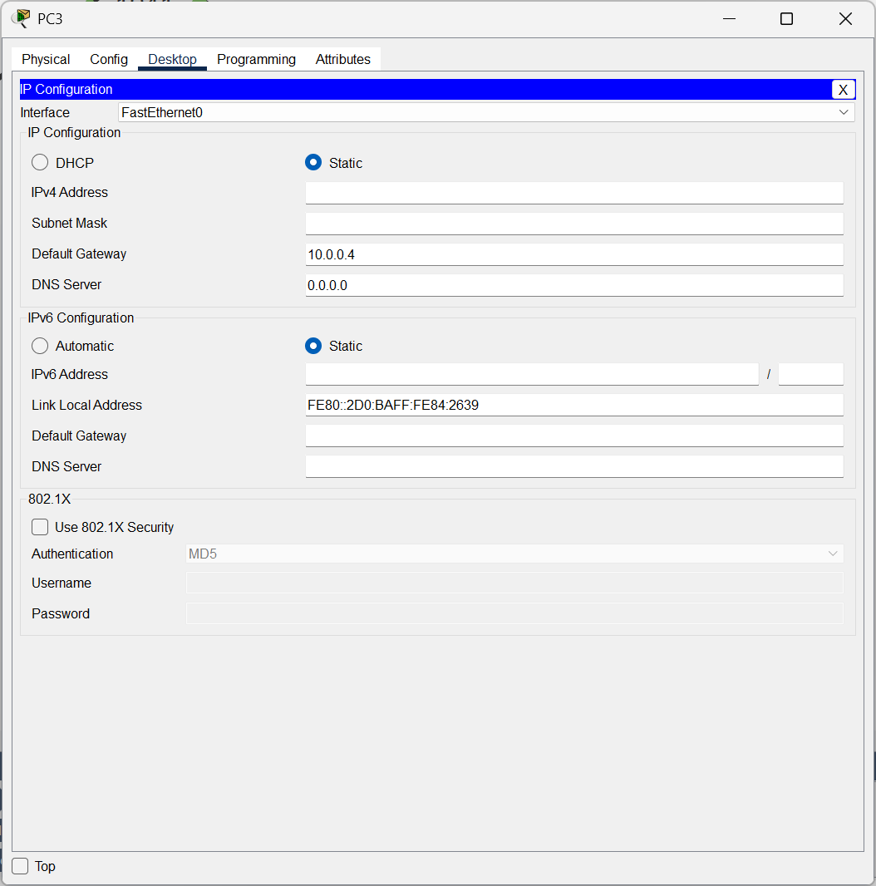

Configure Router0 with giving IPv4 Address as **10.0.0.4 for the network 0.**

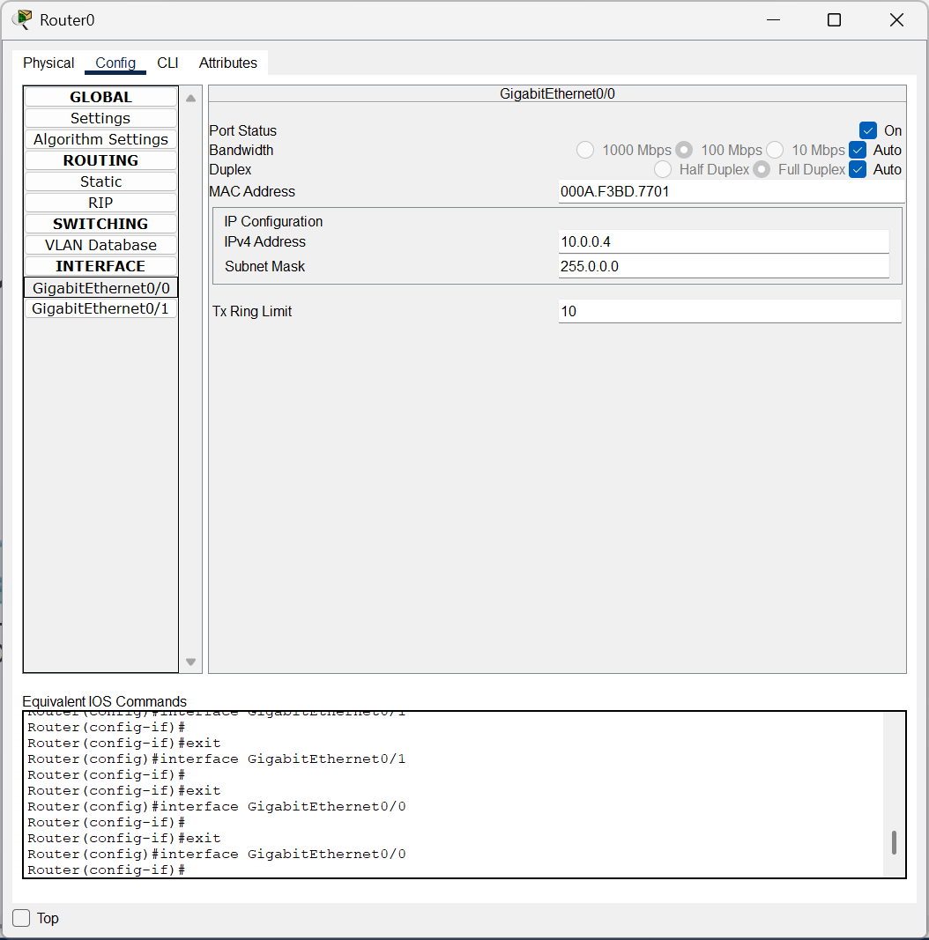

**CISCO PACKET TRACER DIGITAL REPRESENTATION**

***Representation of 2 different networks connected through switches to a Router.***

